A1128-ME-Paleo Hebrew Script-Limestone Cobble-ca 800 BCE



Fig. 1. Paleo Hebrew Script-Limestone Cobble-ca 800 BCE

|  |  |  |  |  |  |  |
| --- | --- | --- | --- | --- | --- | --- |
| K[Khof](https://en.wikipedia.org/wiki/File:Early_Aramaic_character_-_khof.png) | S[Shin](https://en.wikipedia.org/wiki/File:Early_Aramaic_character_-_shin.png) | N[Nun](https://en.wikipedia.org/wiki/File:Early_Aramaic_character_-_nun.png) | M[Mem](https://en.wikipedia.org/wiki/File:Early_Aramaic_character_-_mem.png) | E[Heh](https://en.wikipedia.org/wiki/File:Early_Aramaic_character_-_heh.png) | B[Bet](https://en.wikipedia.org/wiki/File:Early_Aramaic_character_-_Beth.png) | R[Resh](https://en.wikipedia.org/wiki/File:Early_Aramaic_character_-_resh.png) |
| E[Heh](https://en.wikipedia.org/wiki/File:Early_Aramaic_character_-_heh.png) | N[Nun](https://en.wikipedia.org/wiki/File:Early_Aramaic_character_-_nun.png) | S[Shin](https://en.wikipedia.org/wiki/File:Early_Aramaic_character_-_shin.png) | R[Resh](https://en.wikipedia.org/wiki/File:Early_Aramaic_character_-_resh.png) | R[Resh](https://en.wikipedia.org/wiki/File:Early_Aramaic_character_-_resh.png) |  |  |
| M[Mem](https://en.wikipedia.org/wiki/File:Early_Aramaic_character_-_mem.png) | R[Resh](https://en.wikipedia.org/wiki/File:Early_Aramaic_character_-_resh.png) | K[Khof](https://en.wikipedia.org/wiki/File:Early_Aramaic_character_-_khof.png) | S[Shin](https://en.wikipedia.org/wiki/File:Early_Aramaic_character_-_shin.png) | N[Nun](https://en.wikipedia.org/wiki/File:Early_Aramaic_character_-_nun.png) |  |  |
| R[Resh](https://en.wikipedia.org/wiki/File:Early_Aramaic_character_-_resh.png) | S[Shin](https://en.wikipedia.org/wiki/File:Early_Aramaic_character_-_shin.png) | N[Nun](https://en.wikipedia.org/wiki/File:Early_Aramaic_character_-_nun.png) | N[Nun](https://en.wikipedia.org/wiki/File:Early_Aramaic_character_-_nun.png) |  |  |  |
|  | R[Resh](https://en.wikipedia.org/wiki/File:Early_Aramaic_character_-_resh.png) | N[Nun](https://en.wikipedia.org/wiki/File:Early_Aramaic_character_-_nun.png) |  |  |  |  |

Fig. 2 Transcription of Paleo Hebrew Script-Limestone Cobble-ca 800 BCE

**Case no.: 2**

**Accession Number: A1128**

**Formal Label:** Paleo Hebrew Script-Limestone Cobble-ca 800 BCE

**Display Description:** Paleo-Hebrew stone document composed between 900 and 600 BCE on a limestone cobble, which was sent to a friend or business partner named “NoMo”.

**LC Classification:**  PJ4589

**Date or Time Horizon:** ca. 800 BCE

**Geographical Area:** Jerusalem

**Map,**

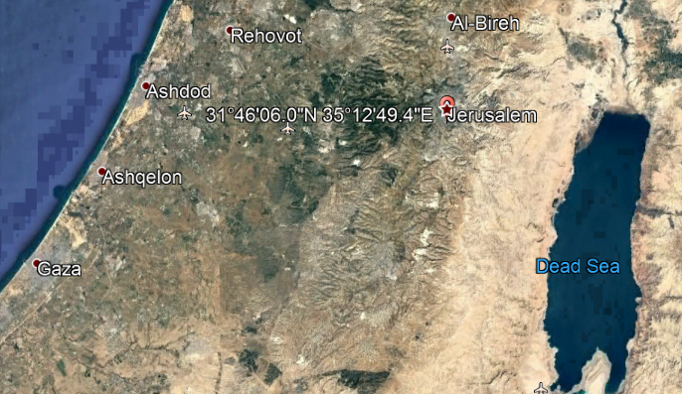

**Location of Jerusalem find spot. Google maps.**

**GPS coordinates: 31.76832 35.21371; 31º46'5.95" N 35º12'49.36" E**

**Cultural Affiliation:** Hebrew

**Media: Limestone, charcoal.**

**Dimensions:** H 5 in, W. 3.5 in.

**Weight:**

**Condition: original.**

**Provenance:** Jerusalem area.

**Discussion:** Thirteen excavated Paleo-Hebrew inscriptions have been identified:

Qadesh Barnea, Beersheba, H al-Kom, Arad, En-Gedi, Lachish, Manahat, Gezer, Tel en Nasba, Tel Qasile, Samaria, Megiddo, Hazor. These are shown on the map in Fig. 3. The current letter is from the Jerusalem area where it was found in a house foundation. Its transcription has been completed and its translation is being researched.

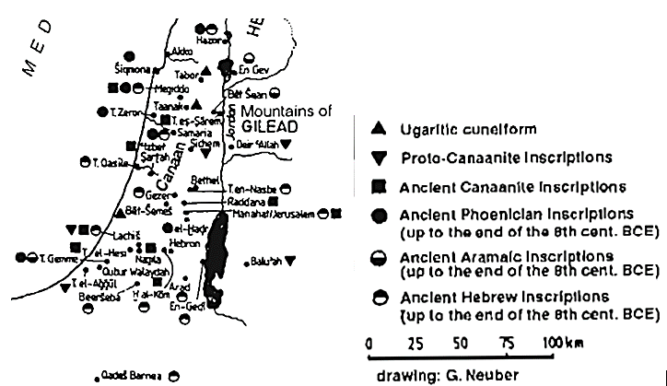

Fig. 3. Levant Scripts, ca 1000-900 BCE. After Watson 1999: 90.

**References:**

Watson, Wilfred G. E. 1999. *Handbook of Ugaritic Studies*. Leiden: Brill.

|  |  |
| --- | --- |
|  |  |